**Deployments in Kubernetes:**

* It is a Kubernetes object or resource in Kubernetes cluster which is used to create the replicas of pods.
* If any one of the pod is go down or deleted it will create automatically without down time.
* Actually deployment will create the replicas and replicas will create the pods.
* We can access the application within a cluster on kubernetes cluster by using cluster ip.

Deployment yaml file

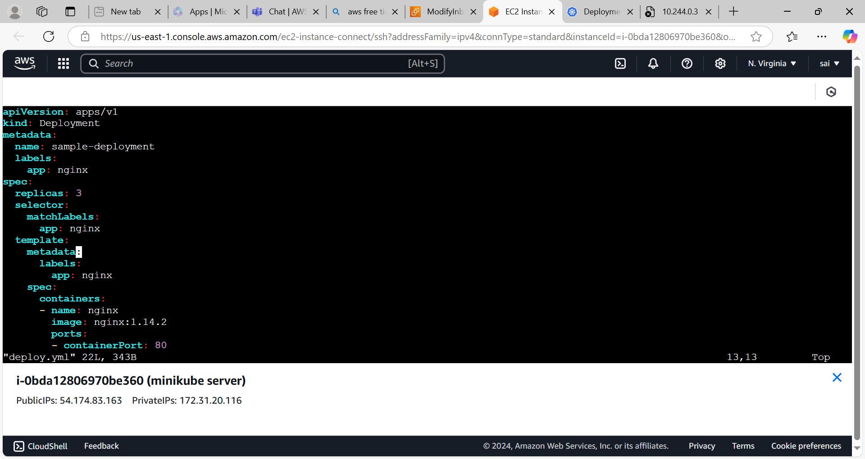

* It will create the pods and deployments.

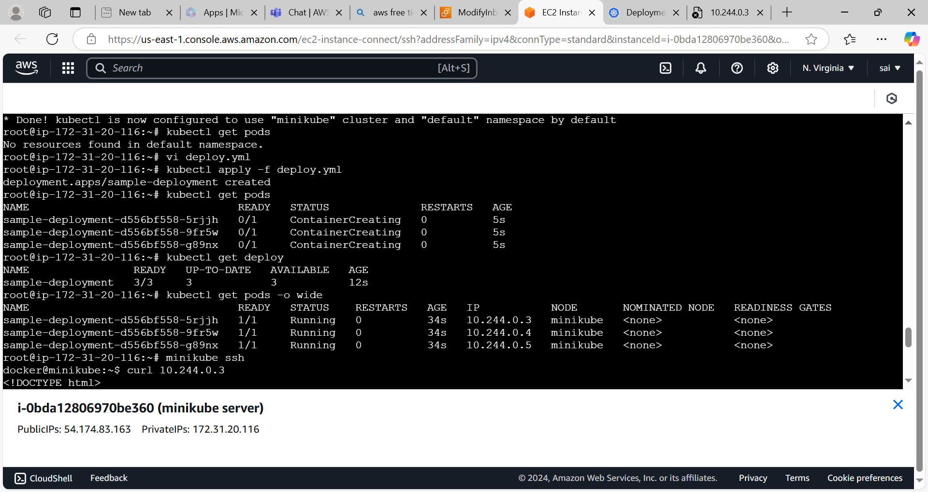

* Login to the minikube cluster by using **minikube ssh** command.
* Use the **curl cluster ip** command.we can access the nginx application inside a Kubernetes cluster.

